EX6 – ADDRESS RESOLUTION PROTOCOL
- S. Vishakan CSE – C 18 5001 196

Server Program:

#include <stdio.h>
#include <stdlib.h>
#include <string.h>
#include <netinet/in.h>
#include <sys/socket.h>

struct ARP_PACKET{
char SRC_IP[100];
char DEST_IP[100];
char SRC_MAC[100];
char DEST_MAC[100];
char DATA[100];
char PKT[600];
};

typedef struct ARP_PACKET arp;

arp createARPPacket(void);

int main(int argc, char **argv){
struct sockaddr_in server, client;
char buffer[1024];
int client_sockets[10], max, fd, sockfd, newfd, ping;
int k, i, len, count;
fd_set newfds;
arp packet;

packet = createARPPacket();
printf("\nDeveloping ARP Request packet\n");
printf("\t%s\n", packet.PKT);
printf("\tThe ARP Request packet is broacasted.\n");
printf("Waiting for ARP Reply...\n");

for(i = 0; i < 10; i++){
client_sockets[i] = 0;
}

sockfd = socket(AF_INET, SOCK_STREAM, 0);

if(sockfd < 0){
perror("Unable to open socket.\n");
}

bzero(&server, sizeof(server));

server.sin_family = AF_INET;
server.sin_addr.s_addr = INADDR_ANY;
server.sin_port = htons(7228);

if(bind(sockfd, (struct sockaddr*)&server, sizeof(server)) < 0){
perror("Bind error occurred.\n");
}

listen(sockfd, 10);

len = sizeof(client);

while(1){
FD_ZERO(&newfds); //Clears socket set.
FD_SET(sockfd, &newfds); //Add sockfd to socket set.
max = sockfd;

for(i = 0; i < 10; i++){
fd = client_sockets[i];
if(fd > 0){
FD_SET(fd, &newfds);
}

if(fd > max){ //Store the max valued FD.
max = fd;
}
}

//Wait indefinitely till any client pings.
ping = select(max+1, &newfds, NULL, NULL, NULL);

if(ping < 0){
perror("Select error occurred.\n");
}

//if sockfd change => new connection request.
if(FD_ISSET(sockfd, &newfds)){
newfd = accept(sockfd, (struct sockaddr*)&client, &len);
if(newfd < 0){
perror("Unable to accept the new connection.\n");
}

strcpy(buffer, packet.PKT);
send(newfd, buffer, sizeof(buffer), 0);

//Add the new client on an empty slot.

for(i = 0; i < 10; i++){
if(client_sockets[i] == 0){
client_sockets[i] = newfd;
break;
}
}
}

//Broadcast on all established connections
for(i = 0; i < 10; i++){
fd = client_sockets[i];
bzero(buffer, sizeof(buffer));

//Check for change in FD
if(FD_ISSET(fd, &newfds)){
recv(fd, buffer, sizeof(buffer), 0);

//Check ARP response
if(buffer[0]){
printf("\nARP Reply received: %s\n", buffer);
count = 0;
k = 0;
for(i = 0; buffer[i]; i++){
if(count == 3){
packet.DEST_MAC[k++] = buffer[i];
}
if(buffer[i] == '|'){
count++;
}
}
packet.DEST_MAC[k] = '\0';

printf("\nSending the packet to: %s\n", packet.DEST_MAC);
bzero(buffer, sizeof(buffer));

strcpy(buffer, packet.PKT);
strcat(buffer, "|");
strcat(buffer, packet.DEST_MAC);
strcat(buffer, "|");
strcat(buffer, packet.DATA);
send(newfd, buffer, sizeof(buffer), 0);
printf("\nPacket Sent: %s\n", buffer);
}
}
}

}

return 0;
}

arp createARPPacket(void){
arp packet;

printf("\nEnter the details of packet received.\n");
printf("Source IP\t: ");
scanf(" %s", packet.SRC_IP);
printf("Source MAC\t: ");
scanf(" %s", packet.SRC_MAC);
printf("Destination IP\t: ");
scanf(" %s", packet.DEST_IP);
printf("16 bit data\t: ");
scanf(" %s", packet.DATA);

strcpy(packet.PKT, packet.SRC_IP);
strcat(packet.PKT, "|");
strcat(packet.PKT, packet.SRC_MAC);
strcat(packet.PKT, "|");
strcat(packet.PKT, packet.DEST_IP);

return packet;
}

Output:

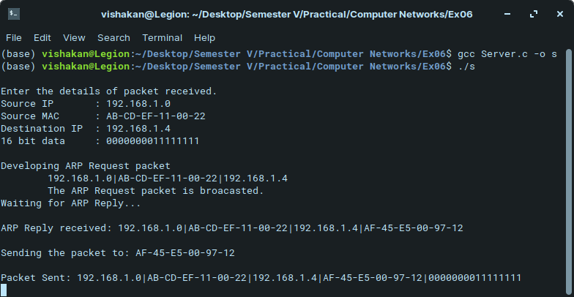
Client Program:

#include <stdio.h>
#include <stdlib.h>
#include <string.h>
#include <netinet/in.h>
#include <sys/socket.h>

struct ARP_PACKET{
char SRC_IP[100];
char DEST_IP[100];
char SRC_MAC[100];
char DEST_MAC[100];
char DATA[16];
char PKT[600];
};

typedef struct ARP_PACKET arp;

int main(int argc, char **argv){
struct sockaddr_in server, client;
char buffer[1024];
int sockfd, newfd;
int len, i, count, k;
arp packet;

printf("\nEnter the IP Address\t: ");
scanf("%s", packet.DEST_IP);
printf("\nEnter the MAC Address\t: ");
scanf("%s", packet.DEST_MAC);

sockfd = socket(AF_INET, SOCK_STREAM, 0);

if(sockfd < 0){
perror("Unable to open socket.\n");
}

bzero(&server, sizeof(server));

server.sin_family = AF_INET;
server.sin_addr.s_addr = inet_addr(argv[1]);
server.sin_port = htons(7228);

connect(sockfd, (struct sockaddr*)&server, sizeof(server));
len = sizeof(client);

bzero(buffer, sizeof(buffer));
recv(sockfd, buffer, sizeof(buffer), 0);
printf("\nARP Request Received: %s\n", buffer);

count = 0;
k = 0;
for(i = 0; buffer[i]; i++){
if(count == 2){
packet.SRC_IP[k++] = buffer[i];
}
if(buffer[i] == '|'){
count++;
}
}

packet.SRC_IP[k] = '\0';

if(strcmp(packet.SRC_IP, packet.DEST_IP) == 0){
printf("\nIP Address matches.\n");
strcat(buffer, "|");
strcat(buffer, packet.DEST_MAC);
send(sockfd, buffer, sizeof(buffer), 0);
printf("\nARP Reply Sent: %s\n", buffer);

bzero(buffer, sizeof(buffer));
recv(sockfd, buffer, sizeof(buffer), 0);
printf("\nReceived Packet is: %s\n", buffer);
}

else{
printf("\nIP Address does not match.\n");
}

close(sockfd);

return 0;
}

Output:

